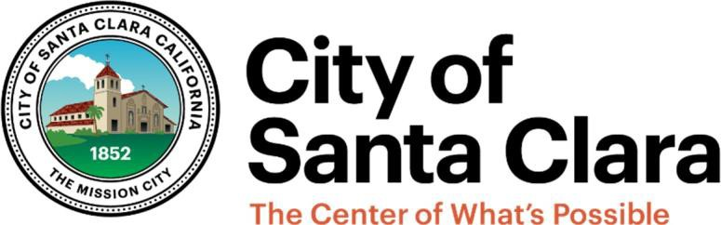

PARKS & RECREATION COMMISSION
CHARTER, PRIORITIES, AND WORK PLAN
FY 2026/27

CITY CHARTER

The City of Santa Clara charter includes the following sections that mandate the formation of a Parks & Recreation Commission and its role.

Sec. 1008 Parks & Recreation Commission.

There shall be a City Parks & Recreation Commission consisting of seven members to be appointed by the City Council from the qualified electors of the City, none of whom shall hold any paid office or employment in the City government.

Sec. 1009 Parks & Recreation Commission – Powers and duties (Mission).

The Parks & Recreation Commission shall have power and be required to:

- Act in advisory capacity to the City Council in all matters pertaining to parks, recreation, playgrounds, and entertainment;

- Consider the annual budget of the Parks & Recreation Department during the process of its preparation and make recommendations with respect thereto to the City Manager and the City Council; and

- Assist in the planning and supervision of a recreation program for the inhabitants of the City, promote and stimulate public interest therein and to that end, solicit to the fullest extent possible the cooperation of school authorities and other public and private agencies interested therein. (Amended by electors at an election held March 7, 2000, Charter Chapter 11 of the State Statutes of 2000)

COUNCIL PRIORITIES
Will be developed May – June 2026

VISION STATEMENT
Enrich the lives and enhance the health and wellbeing of our community by supporting a vibrant, active quality of life for all ages, abilities and interests through excellent parks and recreational facilities, community services, programs, and events.

PRIORITIES
Based on the Commission charter, Council Priorities, the above vision statement, values, and context from prior years, the Commission has defined its priorities and goals for the current fiscal year. The priorities are presented in this section and the goals emanating from these priorities are stated in the following section.
  - Assess facility and program conditions and recommend prioritized maintenance and improvements to facilities and programming. Include in the master plan as appropriate.

  - Identify gaps in infrastructure and programs by neighborhood. Include recommendations for updates to the master plan.

  - Identify opportunities for increasing community participation and current impediments. Recommend ways to enhance community participation and experience.

  - Review the current year Art & Wine Festival, feedback received, and lessons learned, and plan for next year’s Art & Wine Festival.

GOALS

Goal #1:
A. Review park site and facility condition assessments and recommend priorities given existing and anticipated service levels and available resources
Action(s) | Ad Hoc Subcommittee | Timeline | Notes | Measurable Outcomes

Goal #2:
- Review and solicit community input on the existing City park rehabilitation projects based on the current Capital Improvement Program (CIP) Budget and schedule; and

- Review residential developer proposed schematic designs for new neighborhood parks that serve new residential development;
Action(s) | Ad Hoc Subcommittee | Timeline | Notes | Measurable Outcomes

Goal #3:
- Host and develop recommendations for the annual Santa Clara Art & Wine Festival;

- Participate in Citywide Special events; and,

- Plan additional citywide special events.
Action(s) | Ad Hoc Subcommittee | Timeline | Notes | Measurable Outcomes

Goal #4:
A. Participate in the Parks & Recreation Master Plan Implementation
Action(s) | Ad Hoc Subcommittee | Timeline | Notes | Measurable Outcomes

Goal #5:
A. Consider the annual budget of the Parks & Recreation Department during the budget preparation process and make recommendations with respect thereto to the City Manager and City Council.
Action(s) | Ad Hoc Subcommittee | Timeline | Notes | Measurable Outcomes

