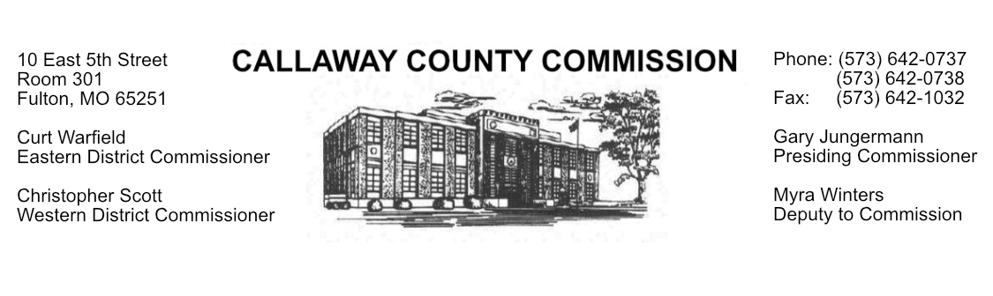
MEETINGS INVOLVING THE CALLAWAY COUNTY COMMISSION:
Unless otherwise noted, meetings are held at the Callaway County Courthouse, Room 301, 10 East 5th Street, Fulton, MO.
All meetings are open to the public unless otherwise noted.

Tentative Agenda
Wednesday, May 06, 2026

Today’s Scheduled Meetings:

- 8:00 a.m. – 4:30 p.m. Business of a general nature.
- 8:00 a.m. – 12:00 p.m. Capital Open Session for Commissioners in Jefferson City, MO.
- 2:30 p.m. 3C’s Award Bid #15 – Collector’s Mailing Service.

General County business shall be conducted Monday through Friday, between the hours of 8:00 a.m. and 4:30 p.m., which may include, but is not limited to, the following activities:
- The Callaway County Commission will have budget discussions throughout the day.
- The Callaway County Commission will have discussions with County legal counsel throughout the day.
- The Callaway County Commission will have discussions and meetings regarding capital projects and other building projects throughout the day.
- The Callaway County Commission will have opioid fund discussions and meetings throughout the day.
- The Callaway County Commission will conduct business of a general nature.
- The Callaway County Commission will have ARPA fund discussions and meetings throughout the day.
- The Callaway County Commission will have discussions regarding opioid litigation fund use throughout the day.
- The Callaway County Commission will meet with citizens throughout the day.
- The Callaway County Commission will meet with elected officials daily.
- The Callaway County Commission will meet with various Commission staff members throughout the day.
- The Callaway County Commission may participate in interviews for open positions throughout the day.
- The Callaway County Commission may attend social events weekly after hours and on weekends.
- The Callaway County Commission may have discussions regarding opioid funds throughout the day.
- The Callaway County Commission may meet with external auditors throughout the day.
Callaway County Commissioners work Monday through Friday, 8:00 a.m. – 4::30 p.m., and daily, the Callaway County Commission will conduct business of a general nature and consider other issues that may come before the commission each day. The Callaway County Commission may meet with citizens, meet with other elected officials, meet with staff, and discuss and possibly sign purchase orders throughout the day. The Callaway County Commission may approve payment requisitions, approve accounts payable reports, or approve previous meeting minutes throughout the day.

